Norfolk County Council proposes to make a Temporary Traffic Regulation Order (the “Order”) (STRO13818) affecting the C215 Hall Road from its junction with U35071 Elsing Road to its junction with U65067 Pound Lane (the “Road”) in the Parish of Elsing to facilitate HRA patching works, the Road will be temporarily closed (except for pedestrian access) for the duration of the works/period the closure is necessary which is anticipated to be from 4th to 10th February 2026, but may continue to be closed/restricted until the 24th March 2026 where the closure is still required beyond the anticipated dates.

Alternative route is via: C215 Hall Road, C213/ C212 Church Street, C212 Moor Lane/ Peaseland Green, C198 Lyng Road/ Main Road, C489 Main Road, C888 Mowles Road, C215 Elsing Lane (North Tuddenham, Elsing).

The works promoter for this restriction/closure is: Norfolk County Council.

Vehicular access will be permitted to a final destination in the Road where signs indicating such access is possible and permitted are in place.

The Order shall automatically revoke on the completion of the works when the closure is no longer necessary or otherwise on the 24th March 2026 without further notice.

If necessary, the restriction could run for a maximum period of 18 months from the date the Order is effective.

A person who contravenes, or who uses or permits the use of a vehicle in contravention of the closure imposed by the Order shall be guilty of an offence.

Penalty: £1000 maximum fine on conviction and/or endorsement for contravention.

In the event of the start date being delayed the new start date will be displayed on site in advance.

Full details on the closure are available at https://one.network. Any enquiries that cannot be answered on the one.network website should be directed to the South Area Streetworks (Infrastructure Department) contactable by telephone at 0344 800 8020 or email at streetworks@norfolk.gov.uk

Dated this 23rd day of January 2026.

Katrina Hulatt
Director of Legal Services (nplaw)
County Hall
Martineau Lane
Norwich
NR1 2DH

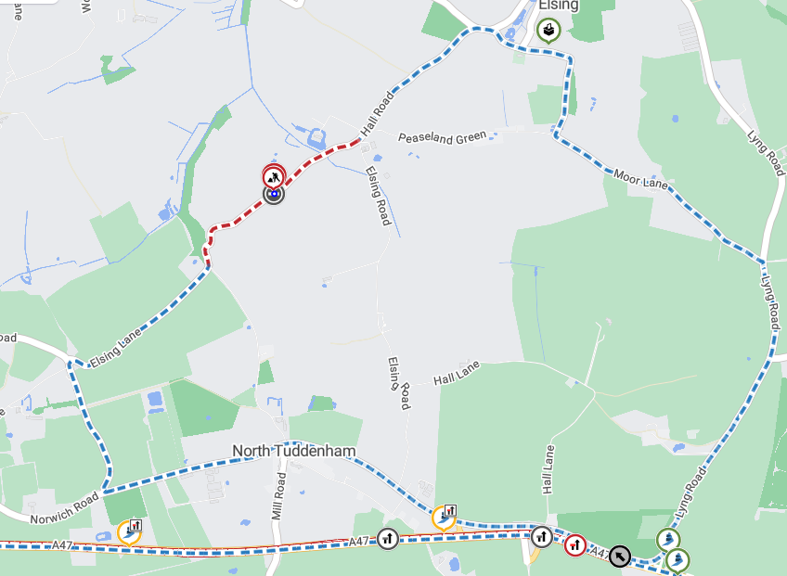

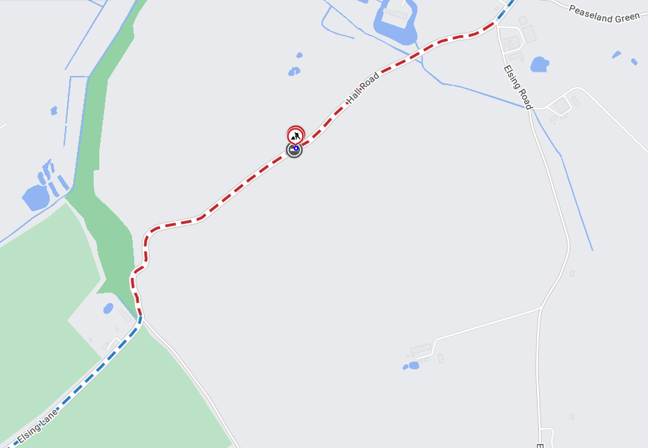
Imagery © 2025 MapTiler | Imagery © 2025 Hexagon | © MapTiler © OpenStreetMap contributors

