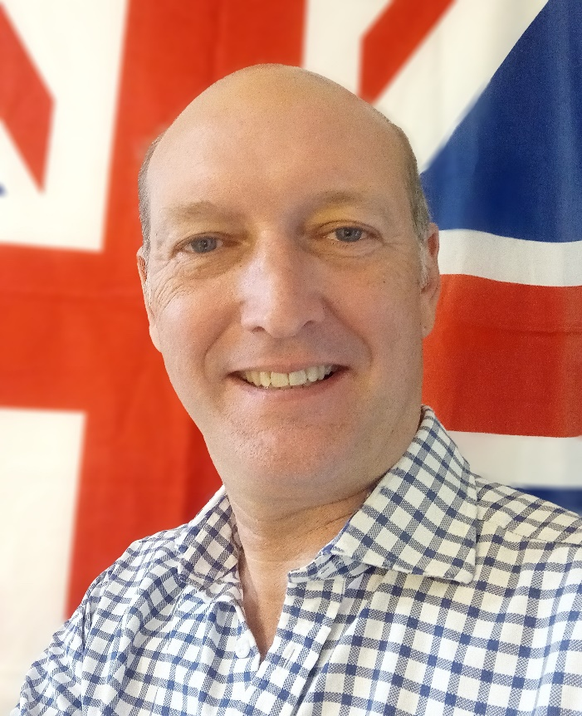
Cllr BILL BORRETT
Parish report for the Elmham and Mattishall Division
September 2025
Contact: bill.borrett@hotmail.co.uk
I hope that you have had some time off over the Summer Holidays. It has been busy for me however due the Government’s twin projects that will change Local Democracy here in in Norfolk permanently.
September 26th is the deadline by which all proposals for Unitary Local Government must be submitted by. The current arrangements are not an acceptable option for the Government, so the County Council and Breckland Council will definitely be abolished in 2027.
Thank you for your feedback to futurenorfolk.com that I asked for in my July Newsletter, it has really helped shape the proposals that we will put to the Government.
I will be supporting the three Unitary Option with a West Norfolk Council (which will include Breckland), Greater Norwich Council and an East Norfolk Council. This will protect the ability for Residents to have a say locally and keep the Council Tax down as much as possible.
The Governments second Project is establishing a new Mayor who will cover Norfolk and Suffolk together, this will mean the establishment of a new Strategic Authority for Norfolk and Suffolk which the Mayor will run. There will be a meeting in October at the County Council where this will be considered. I will keep you updated.

Norwich Castle Keep open following a £27m redevelopment with Lottery money
Norwich Castle Keep reopened to visitors following a comprehensive five-year redevelopment project that introduced new accessibility features alongside new galleries and interpretive displays.
Run by Norfolk County Council with a huge grant from the National Lottery Heritage Fund, all five floors of the original Royal Palace were opened to the public for the first time ever.
The Grade I listed castle, originally commissioned by William the Conqueror 900 years ago and completed by his son Henry I in 1121, retained its historic significance while embracing modern improvements.
A new light-filled atrium adjacent to the Keep was unveiled in the first phase of the redevelopment in July 2024. Visitors also benefited from a new café, gift shop, and additional toilet facilities to enhance the visitor experience.
As part of the refurbishment a lift was installed to provide full wheelchair accessibility throughout the Keep, allowing access from the basement all the way up to the battlements, where visitors can enjoy panoramic views across Norwich.

Nationally recognised 'AI’ programme to be rolled out across Norfolk to support vulnerable residents and help prevent falls
A new, nationally recognised proactive intervention scheme is rolling out across the whole of Norfolk. The initiative will be delivered in collaboration with local partners including Voluntary, Community and Social Enterprises (VCSE), city, district and borough Councils and NHS organisations, aims to reduce falls in vulnerable and older adults.
Following a successful pilot with 1250 residents, the programme, which uses Artificial Intelligence (AI) to identify residents at risk of escalating needs, enhances the safety and wellbeing of those at risk of falls. The latest Artificial Intelligence technology, natural language processing is used to 'read' case notes and automatically extract meaningful insight about our residents. This technology enables the council to identify and prioritise individuals in Norfolk most at risk of falling, allows for proactive intervention before they fall.
AI is a rapidly developing technology with the potential to improve the delivery of services. The council is using AI to benefit the people of Norfolk in a safe, ethical and transparent way.
Falls are a major concern, particularly among older or vulnerable adults, and can lead to severe injuries and a decline in quality of life. Through this programme, the council will be able to predict people who are at higher risk and offer timely and targeted interventions to support them.
For more information about preventing falls visit Preventing and dealing with falls.

Congratulations and support extended to further education students on results day
Students across the country received their A level, T Level and Level 3 VTQs results.
Every year sees students facing decisions over what to do next with a growing variety of options available for young people at 18.
There's lots of support available to all students, whatever their grades and plans, so they can make decisions about next steps with clear advice on courses and careers.
There's also plenty of help and advice for those who may have not done as well as expected, have changed their mind about their plans, or who don't have anything in place for September.
- Norfolk County Council's Help You Choose website offers information and support to young people with the different options available to them and advice on next steps whatever their results. The section "Choices at 18+" includes links and support with education & learning, CV writing, apprenticeship vacancies, health and wellbeing, voluntary work, work experience, information about different careers, and much more. There is also a section for parents or carers to help them understand the different options for their young person.
- UCAS offers guidance to support students through the process of securing a university place with information about insurance choices and clearing. Anyone who has just missed out on the grades they need they should contact the admissions team at their preferred university, as they may still be able to offer them a place. There are already nearly 30,000 courses available in clearing this year so there will be plenty of high-quality choices available.
- Students can find out more about education and training choices by visiting Post 18 options | National Careers Service. During the exam results period, the hub will also have key information on resits, clearing, appeals and more. Students can also chat directly to an expert adviser via webchat or by calling the National Careers Service exam results helpline on 0800 100 900 on weekdays between 8am and 8pm and Saturday 10am to 5pm.
- Norfolk and Waveney's Children and Young People's Health Services Just One Norfolk website offers mental health support and helpful advice on managing anxiety.

- Road treatment brings long-term benefits to Norfolk

- Norfolk County Council, in partnership with Roadtechs Group, has successfully completed a record-breaking road rejuvenation project on the A1066 near Thetford, delivering long-term benefits for local communities, businesses and the environment.
- In just under five hours, over 9km of the A1066 was treated with Reclamite, a sustainable asphalt rejuvenator that extends the life of road surfaces and helps prevent potholes. This marks the largest area of highway ever to be treated with Reclamite in a single shift in the UK.
- The A1066 is a vital route connecting Thetford and Diss, serving local residents, businesses, and the Shadwell Estate. By completing the work in one shift under a full road closure, the Council significantly reduced disruption for road users, reopening the road before the evening rush hour.
- This treatment is designed to extend the life of the surface to prevent it needing full resurfacing at a cost of £3.7 million and taking up to 11 weeks to complete. Instead, this innovative approach has saved time, money, and carbon, producing just 2.31 tonnes of CO₂e compared to 508 tonnes for a traditional resurfacing project.
- This successful project will act as a blueprint for other road schemes.

Repton Property Company delivers £1 million dividend
Repton Property Developments, Norfolk County Council's wholly-owned property development company, has announced a £1 million dividend to the County Council after a successful 2024/25 financial year. The money will be used to help fund services to residents.
This follows a £735,000 dividend paid out last year, bringing the total returned to the authority to over £1.7 million in just two years.
Established in July 2017, Repton was created with the aim of unlocking the value of underutilised council-owned land and buildings, while generating financial returns to ease the pressure on the public purse.
Since its inception, Repton has focused on building high-quality and environmentally conscious housing developments across Norfolk.

Long Stratton Bypass opens to traffic
Finally, after a County Council campaign lasting many years, Motorists using the A140 south of Norwich begun using the long awaited Long Stratton Bypass for the first time during August.
This project is a true collaboration along with South Norfolk Council and Norfolk Homes, with developer contributions and major funding commitments from The Department for Transport, Greater Norwich Growth Board supporting the project's (£46.9m) overall budget.

Norfolk celebrates 2 million journeys by Beryl Bikes in Norwich
Norfolk County Council, in partnership with Beryl and National Grid, is celebrating a major milestone for the county's innovative shared transport scheme, which has now recorded more than two million journeys since its launch in March 2020.
The total of 2,057,859 trips covers an impressive 5.79 million kilometres, the equivalent of riding around the world 144 times. By swapping car journeys for two wheels, riders have helped save around 990 tonnes of CO₂, keeping Norwich's air cleaner, streets less congested, and communities healthier.
Over 100,000 people have used the scheme, with the average active rider taking 20.8 trips.
Journeys are made up of:
- 424,186 pedal bike rides
- 407,292 e-bike rides
- 1,226,350 e-scooter rides
Feedback from users shows that 41% of these journeys would otherwise have been made by driving or being a passenger in a private car, and a further 24% would have taken a taxi or ride-hailing service, while 5% would have used a motorbike or moped instead.
For more information, visit the Beryl website.

Thank you for reading this is, if you have any questions, please do not hesitate to contact me.
Best wishes Bill

