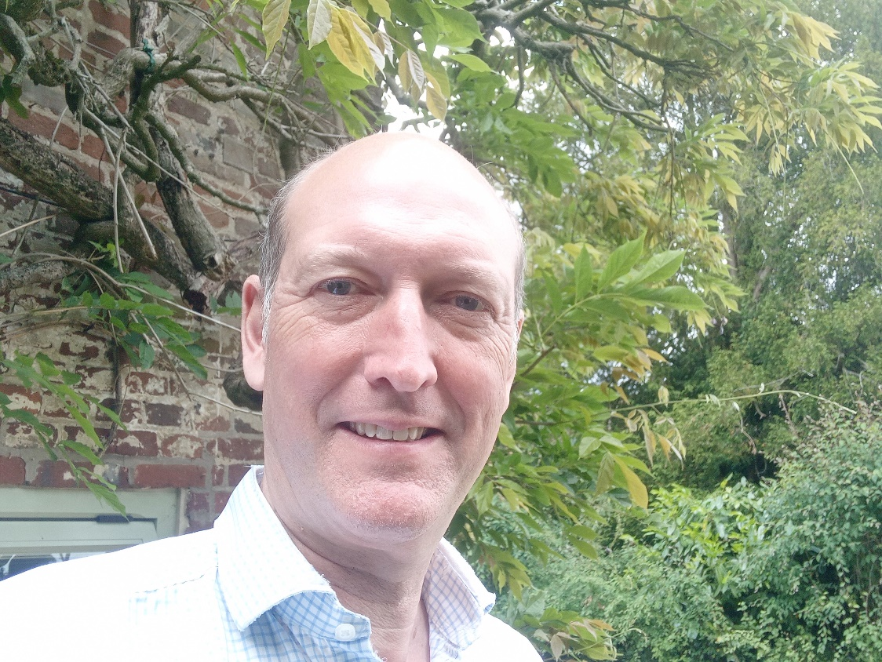

**Cllr BILL BORRETT**

**Parish report for the Elmham and Mattishall Division**

**July 2025**

I apologise if you have been wondering where I am, much to my surprise my appendix burst and I have been in the Norfolk and Norwich. I am glad to say that I have made a complete recovery, but it has got in the way of everything.

**The Government has announced its new Devolution and Local Government Bill this week. (Called the English Devolution and Community Empowerment Bill)**

If only it did what it says on the tin. It includes the following:

It introduces the Supplementary Vote System for electing Mayors and Police and Crime Commissioners. Removing the first past the post system currently used.

Direction powers. The Bill introduces a power for the Secretary of State to direct a Council(s) to develop and submit proposals for Local Government Reorganisation.

The Bill will create a new Ministerial power to enable the Secretary of State to mandate the creation of new Strategic Authorities (SA’s) with a directly elected Mayor, without the consent of the relevant Councils in areas where one does not already exist. This removes any local choice, and it looks like the Government will impose the extra layer of Government in the form of a Strategic Authority for Norfolk and Suffolk with a Mayor whether we want one or not. I am extremely disappointed as it takes the decision away from Norfolk and gives it to the Minister in London.

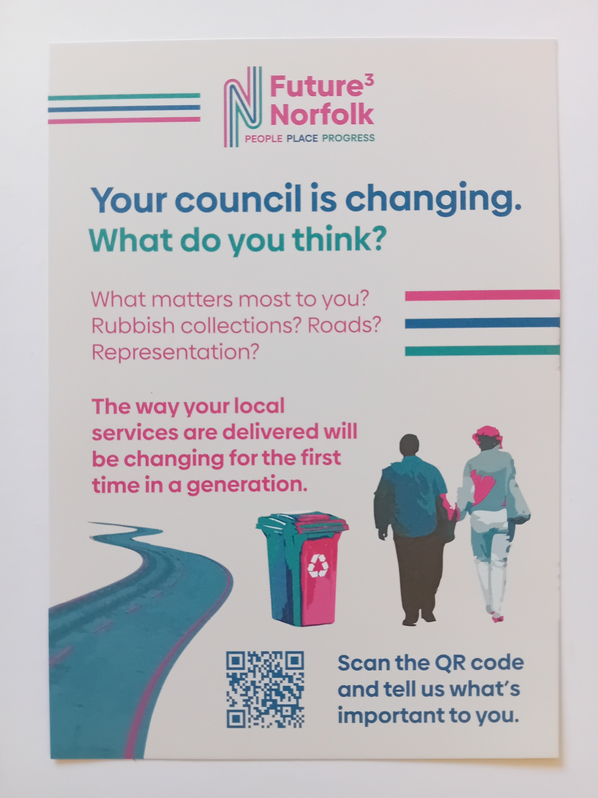

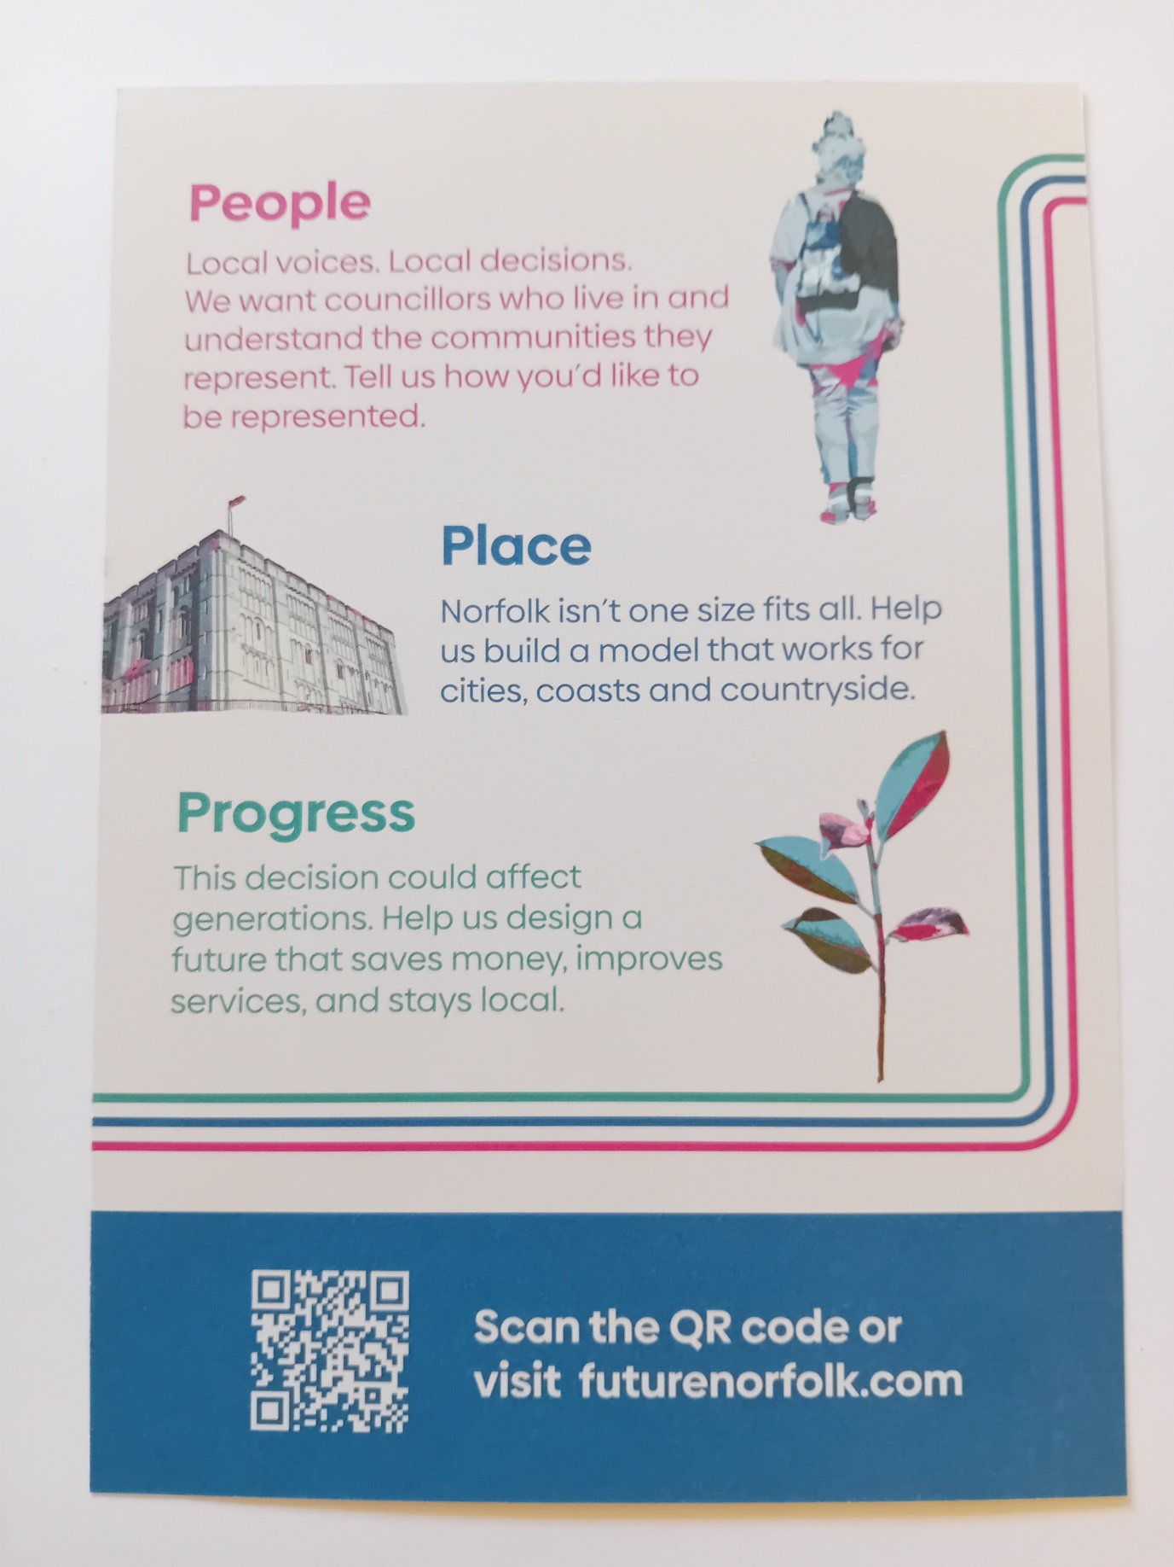

Despite everything I still want everyone to have an opportunity for you to have your say, Future Norfolk is the route to do it, it has been set up by a consortium of Norfolk’s Councils and we will submit all your thoughts to the Government in advance of their decisions, so please take the time to go online and respond.

**Community Fund**

From 1st July, local groups across Norfolk can apply for funding through the newly launched Norfolk Community Fund. The Norfolk Council Council grant scheme is designed to support grassroots organisations at the heart of every community.

Each of Norfolk's 84 county councillors has been allocated £5,000 to distribute within their division, ensuring that funding decisions are made by those who know their communities best.

The fund offers grants between £200 and £2,500 to support projects that promote things like social inclusion, volunteering, and community engagement.

For grants of £500 or more, groups will be asked to match 50% of the funding through a Crowdfunding platform, potentially doubling the impact. Smaller grants under £500 do not require match funding, though groups are welcome to crowdfund to increase their total.

With an estimated 10,000 voluntary, community, and social enterprise (VCSE) organisations in Norfolk, including 3,500 registered charities and 6,500 informal groups, the fund aims to provide a vital boost at a time when many are facing financial pressures.

If you are part of a local group and you could benefit from a grant, contact your local county councillor with details of your project and the funding you need. You can find their contact details on the Norfolk County Council website.

For more information about the Norfolk Community Fund, visit [**norfolk.gov.uk/communityfund**](https://www.norfolk.gov.uk/article/70197/Norfolk-Community-Fund)

**Norfolk's market towns invited to apply for grants to attract more visitors**

Projects that are aimed at increasing sales and footfall in market towns will be able to apply for grants of between £1,000 and £5,000 through an initiative being rolled out across the whole of Norfolk.

Organisations and businesses are being invited to apply for the Love Your Market Town fund's Pride of Place grants to fund ideas designed to encourage people to visit and shop in their local towns more frequently. The scheme is supported by Norfolk County Council and applicants have until 31st August to submit their ideas.

Once ideas have been submitted, they will be reviewed by an independent panel and applicants notified of the outcome by Tuesday 30th September.

Applications are welcome from any local groups or business, but any activity must be a brand-new idea and should support multiple areas or services within a Norfolk market town. There is no limit to the kind of activities that can be funded but the idea must have a link to creating interest or increasing footfall in town centres.

[**Find more information or express an interest in bidding for a grant via the New Anglia Growth Hub**](https://www.newangliagrowthhub.co.uk/love-your-market-town-pride-of-place-funding/).

**More than £3.8m pledged to support apprenticeships through Norfolk levy scheme**

Over £3.8m has been pledged by over 30 donating companies in the first two financial years of Apprenticeships Norfolk's Levy Support Scheme, and more than £3.2m has now been transferred to more than 160 businesses - triple the original £1m target.

The aim of the Levy Support Scheme is to connect businesses to share unspent apprenticeship levy funds through levy transfers, and to offer a bespoke matching service and wraparound support to Norfolk employers.

Donating businesses have included Amazon, RWE, and Norfolk and Norwich University Hospital, while Flagship, Norwich School of Hair & Beauty and Sheringham Little Theatre have been among those which have received funds.

[**Learn more about the impact report on the Apprenticeships Norfolk website**](https://apprenticeshipsnorfolk.org/levy-support-scheme/info/lss)

**Norfolk County Council Ranked Among best for Climate Action**

Norfolk County Council has been recognised as one of the top-performing local authorities in the UK, according to the latest Climate Action Scorecards.

Published by Climate Emergency UK, the scorecard evaluates councils on key areas such as green energy, sustainable transport, and environmental stewardship.

Norfolk County Council has achieved third place among all county councils in the UK, cementing its position as a national leader in climate action. Its overall score has improved by 3 percentage points since 2023, making it the top-performing council in Norfolk.

The Climate Action Scorecards are an independent assessment of local authority climate action. The full results can be found at [**https://councilclimatescorecards.uk/scoring/county/**](https://councilclimatescorecards.uk/scoring/county/ )

The county council's key achievements include:

* **100% Green Electricity**: All council-run buildings use fully renewable electricity.
* **LED Streetlights**: Upgrade saves over 1 million kWh and cuts 200+ tonnes of CO₂ annually.
* **Solar Power**: Rooftop panels now supply 2% of council building electricity.
* **Tree Planting**: Over 600,000 trees planted toward a 1 million tree goal.
* **Electric Buses**: 70 buses introduced in Norwich, saving 3,800 tonnes of CO₂ yearly and improving air quality.

**New options assessment work for Norwich Western Link**

Norfolk County Council is planning to explore options for a Norwich Western Link to reduce traffic problems and improve travel west of Norwich.

The Council’s cabinet will be asked to approve this study, which will include public consultation. The options will cover improving current roads, boosting public transport and active travel (walking, cycling), and building new single or dual carriageway routes.

Traffic congestion in the area causes safety issues, business delays, and problems reaching important places like the Norfolk and Norwich University Hospital and Norwich Airport.

Earlier, the Council applied to build a 3.9-mile dual carriageway road but withdrew the plan due to concerns from Natural England about protected barbastelle bats in the area.

Natural England’s new guidance, released just before the application deadline, made the previous road plan unlikely to be approved.

Since then, the Council has talked with the Department for Transport (DfT) and has secured provisional funding of £960,000 (two-thirds of the £1.43 million cost) for the study. The DfT also confirmed no need to resubmit earlier business case documents.

The Council will keep consulting Natural England during the study to ensure any chosen options are acceptable.

As a consequence of the bat concerns and previous feedback, it’s unlikely that a dual carriageway or a viaduct over the River Wensum will be included in the options.

A report will go to the cabinet in July, with results of the study and consultation expected next summer. Then, a preferred option for the Norwich Western Link may be recommended.