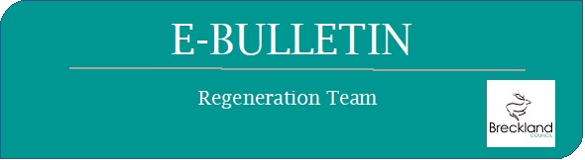

Welcome
This edition is focussed on updates from government around the timeline to re-open, new grants, Lateral Flow Testing and the Spring Back Programme including Re-opening High Streets – Safe Campaign

Government Roadmap to easing out of current restrictions
On 19th February, the Prime Minister announced a 4-step process in getting the country and the economy thriving again. The 4 steps are all based around specific dates with a 5 week period in between each to ensure that we do not have a spike in Covid 19 cases and we can safely reopen our High Streets again.
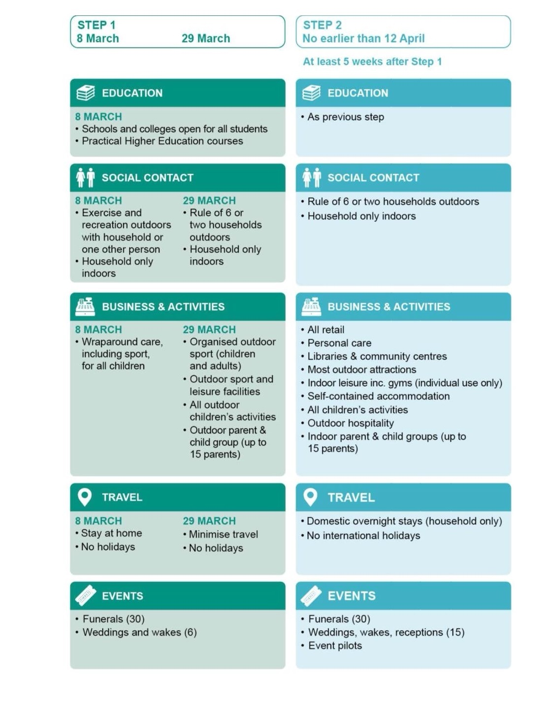

With everything moving in the right direction in March and April we will be able to open further in May as shown in Step 3 and 4.

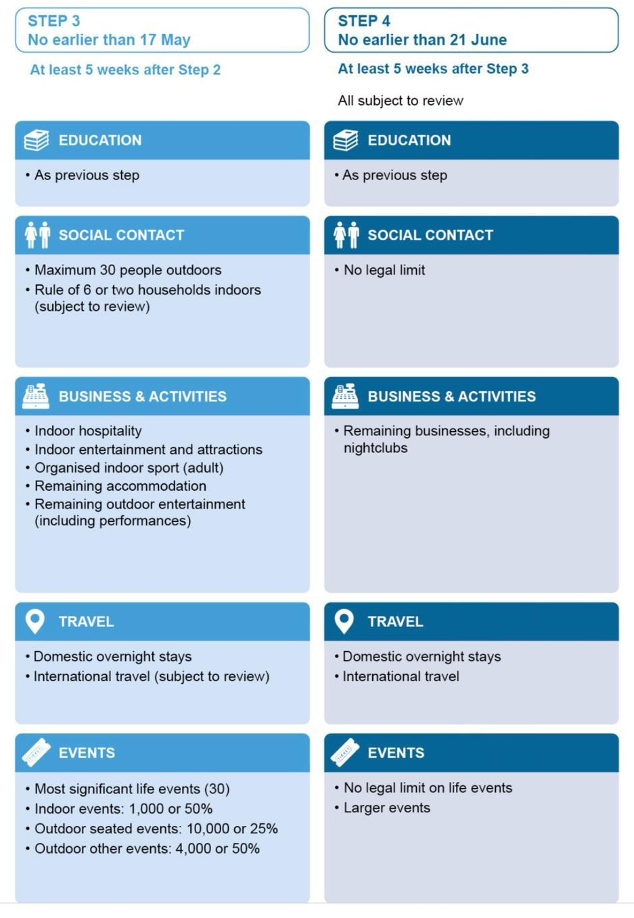

Covid 19 Business Grants
For businesses who have been in receipt of the Local Restrictions Support Grant (LRSG) for the restriction period 5th January to 15th February you will have received an additional payment up to the 31st March. No further applications can be made for this grant period.

For the restriction period 16th February to 31st March applications can be made no later than 31st May 2021.

If your business has been in receipt of the Additional Restrictions Grant (ARG) you will have been paid for the restrictions period from 5th January to 15th February 2021 and then additional payment from 16th February to 12th April. This grant scheme is currently open for any business that has not applied previously and is not entitled to the Local Restrictions Support Grant. Click here for further information and the application form.

Restart grant info

On the 1st April 2021 the Restart Grant goes live, you do not need to apply for this grant. We will be able to support businesses through provision of new “Restart” Grants after 1st April. These grants work based on national criteria, and target businesses in rateable premises (although those in receipt of 100% rate relief are still eligible) based on:

Category | Eligible businesses include | Grants Available (based on RV)
 |  | <£15k | £15–51k | 51k>
Non-essential retail | Retailers whose products are “not necessary to the health and well-being of the public” * | £2,667 | £4,000 | £6,000
Hospitality & leisure | Hospitality, accommodation, leisure, personal care and gym business | £8,000 | £12,000 | £18,000

* BEIS have supplied a long list of non-eligible businesses under non-essential retail, including: food retailers, supermarkets, convenience stores, off licences, breweries, pharmacies, animal rescue centres, building merchants, petrol stations, vehicle repair and MOT services, taxi and vehicle hire businesses, education providers, post offices, funeral directors, laundrettes, vets, storage and distribution facilities, wholesalers, employment agencies.

For more information and guidance to check if you are eligible for the Restart Grant please visit https://www.gov.uk/guidance/check-if-youre-eligible-for-a-coronavirus-restart-grant

New Covid-fightback programme launched – “Spring Back” – helping businesses get ready for the lifting of restrictions.
A new £2m package of support to help businesses fight-back against Covid-19, meet the challenges and the opportunities of the national roadmap head on, and get ready for what is hoped to be a great summer’s trade.
Based on the input and feedback from almost 500 local businesses, the new support programme -- “Spring Back” - is targeted at the specific needs identified for businesses reopening and stepping up trade through to July. It brings together resource from across the Council and taps into several national funding opportunities, as part of a continued whole-council effort to make sure Breckland businesses can look positively to the future.
- Shop Front Improvement Scheme – investing in the biggest ever “Spring Clean” across the District. Any businesses based in Breckland’s primary shopping areas, or any customer facing business, will be able to get financial support for improvements and enhancements to their shop frontage – from a lick of paint through to a replacement frontages – For more information Click Here
- Covid Safe and Adaptions Grants – helping businesses shoulder the burden of trading in a Covid-safe way and meet the challenges of serving under restrictions. Grants of up to £5k will be available to invest in safety; or change business practices. From extra PPE and screens, through to a new marquee or outdoor seating – Click here for more information
- Covid Safe Scheme – helping customers easily see the efforts businesses are making to ensure Covid safety, with a simple accreditation scheme delivered by Breckland Public Protection
- Continued Investment in Shopper Safety – with new and replacement hand sanitiser stations in all busy shopping areas, and friendly Covid Support Officers helping assure safety 6 days a week
- Expanded Enjoy Discover Explore Campaign – promoting and highlighting the local shopping and leisure offer across Breckland, with branding now bespoke to each Market Town
- Digital Breckland – building on the highly successful scheme – Breckland Digital High Streets – enabling any Breckland-based business to get support for their digital offer, with grants towards making key digital changes from a new payment system, through to search engine optimisation. – Click here for more information
- Expanded enterprise and start-up scheme – having already created 10 new businesses since Christmas, we are looking to grow the pipeline of new innovative businesses further. With finance and advice for new entrepreneurs looking to start-up locally – Click here for more information
- Support grants for businesses outside of national schemes –As part of commitment that no business in need goes unsupported, Breckland’s discretionary scheme extends grants to any Breckland-based-business ineligible under national schemes – including self-employed, market traders and mobile traders. – For more information Click here

Click here for more information about the Spring Back Programme

Lateral Flow Testing
Around 1 in 3 people with coronavirus do not have symptoms and can therefore spread the virus without knowing. Symptom-free testing (also known as rapid testing or community testing) is a way to identify people who do not have coronavirus symptoms but are infectious.
A lateral flow test (LFT) detects whether coronavirus is present or not – even in someone who shows no coronavirus symptoms. Lateral flow tests are safe, inexpensive and the results are trusted.
Workplace surveillance testing
If you are interested in workplace surveillance testing and your business has 50 employees or fewer (but more than one), Click here to visit our website for more information and to complete a declaration of interest (DoI) form.

Commercial Waste
Breckland Council are now able to offer a Commercial Waste service enabling you to keep your commercial waste service cost effective and local, which would also mean your carbon footprint is reduced.

In line with the Controlled Waste (England and Wales) Regulations 2012, the commercial waste you produce needs to be disposed of in a controlled fashion and this is where we can help you.
At present, the country is still under certain restrictions making now the perfect time to reassess your commercial waste service before the Prime Minister gives everyone the all-clear to resume trading and moving more freely around the Country.

Another benefit of working with your local council on this is that we are not required to charge VAT on the service.

With charges from as little as £4.65 per empty on recycling and from £6.70 on general waste, we think we can save you money on your current commercial waste arrangement.

If you already know what you require, to request a quote please Click here.

If you have any questions, please do not hesitate to get in touch so we can talk you through your options and help you select the most cost-effective solution for your needs - get in touch with:
Rob Bunting, Commercial Waste Officer will be able to assist you with this in more detail via commercialwaste@breckland.gov.uk

Contact Us

For further information please visit our business support webpage Click here

Should you wish to contact us directly please email regeneration@breckland.gov.uk

