Cllr BILL BORRETT
Parish Report for the Elmham and Mattishall Division
November 2025

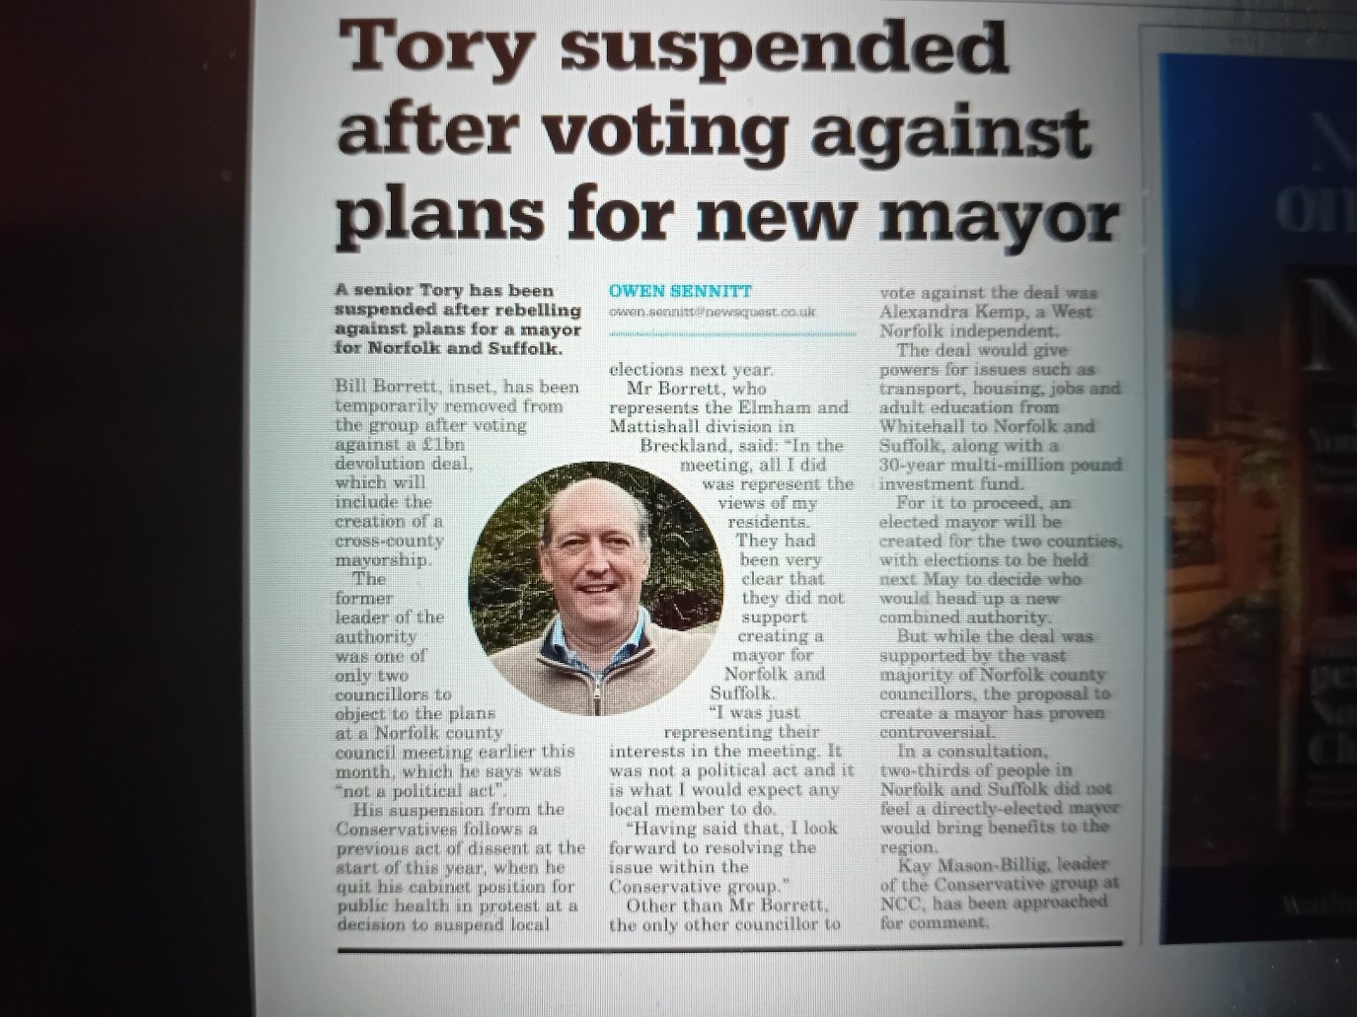

You may have seen this article in the EDP on the 27th October. I am happy to say that I am no longer suspended, but it came about because I listened to your views. I voted against establishing an expensive new Mayor for Norfolk and Suffolk, in line with the feedback I received from you. This was despite being told to vote for it at the County Council.
I have always felt that it is my responsibility to represent the residents of the Elmham and Mattishall Division to the County Council not the other way around. Your views always come first.
New Norfolk-wide highways contract awarded with strong focus on boosting local skills and employment
Norfolk County Council has appointed Kier Limited as its new long-term contractor responsible for the maintenance and construction of Norfolk’s highway network.
Kier will deliver a comprehensive programme of highways maintenance and improvement, including road resurfacing and surface dressing, bridge works, drainage and the delivery of new transport infrastructure.
As part of the contract, Kier will invest significantly in its existing site in Wymondham, upgrading facilities to reduce energy consumption and support the latest in sustainable construction and materials innovation, which will benefit the wider Norfolk economy.
A key feature of Kier's approach to the contract will be its commitment to local skills and employment. At any given time, Kier will employ at least 15 apprentices, providing structured training, professional qualifications, and career pathways for young people across Norfolk.
The company will also run an annual 10-week programme for young people in care and care leavers, offering taster sessions, work experience, and employability skills, with support from supply chain partners.
Most importantly we hope to see quality and timely actions to protect our Highways.

Norfolk bucking national trend for recruiting adoptive parents
Norfolk is bucking the national trend for recruiting adopters, with the numbers of adopters increasing in the county. This is so important as the life chances of children who are adopted are so much greater.
Across the country, there are 12% fewer families considering adoption this year compared to last, whereas in the year 24/25, Norfolk County Council's Adoption Service recruited 43 adoptive households - a 53% increase on the number of adopters who were approved in 23/24.
Of these 43 households, 37 were couples and six were single adopters. The council has also seen an increase in adopters from global majority backgrounds and from the LGBTQ+ community.
The news comes as the county marks “National Adoption Week”, with this year's focus being on busting the misconceptions about who can adopt.
People considering whether adoption is right for them are invited to contact Norfolk Adoption Services on 01603 638343 for a friendly chat and invitation to an information event where they can find out more.
Give Norfolk County Council your views on fire and rescue priorities
A public consultation on Norfolk Fire & Rescue Service's safety and risk plans for the next five years has gone live.
Residents, businesses and organisations now have an opportunity to feedback on areas the service has identified as priorities for 2026-2031, to mitigate risk and keep our county as safe as possible.
Eight proposals have been put out for the public to comment on, around the areas of:
- Road safety
- Prevention activity
- Building safety
- Preparing for and responding to emergencies
- Responding to climate change (specifically extreme weather risks such as flooding and wildfire)
- Supporting our people
- Fire station improvements
- Responding to medical emergencies
Details of the eight proposals are below. The public can fill in an online survey via www.norfolk.gov.uk/crmp to respond.
CRMP Proposal 1
Working to Improve Road safety: We will play a more active role in Norfolk's Road Safety Partnerships to analyse data and coordinate action to reduce the occurrence and impact of collisions on our county's roads.
CRMP Proposal 2
Focussing on prevention: We will work within Community Safety Partnerships to further focus on vulnerable groups, including children and young people. We will increase our early intervention activities, developing resilience in our communities and improving outcomes.
CRMP Proposal 3
Ensuring better Building Safety: We will prioritise inspection and engagement activity for the highest risk buildings in Norfolk, effectively applying legislation across relevant residential and commercial buildings to keep people safe in their homes, at work and during their leisure activities.
CRMP Proposal 4
Enhancing our Response: We will review how we locate and deploy our assets and resources to optimise how we train for, and respond to, emergencies.
CRMP Proposal 5
Responding to Climate Change: We will review our extreme weather response, specifically water and wildfire capability, to mitigate the impact of these incidents. We will continue to lobby government to make water and flood response a statutory duty for all Fire and Rescue Services in England.
CRMP Proposal 6
Supporting our People: We will continue to further develop our high performing and inclusive culture; supporting our staff to be skilled, healthy and engaged, and empowering them to uphold the highest professional standards that our communities expect.
CRMP Proposal 7
Providing Fit for Purpose Fire Stations: We will secure long term investment in our fire stations, so firefighters are protected from contaminants and facilities are fit for a modern workforce.
CRMP Proposal 8
Responding to Life Threatening Medical Emergencies: We will continue to develop our work with East of England Ambulance Service Trust around Emergency Medical Response to improve outcomes for our communities.

Norfolk's budget consultation - Have your say
As the County Council's annual budget consultation has launched, residents are urged to take a look at the proposals and have their say.
The County Council is working to set a balanced budget, despite increased demand for services from Norfolk’s residents.
This year there are 50 budget saving proposals, and proposals to increase Council Tax, which provides a large part of the funding the County Council needs to meet it’s growing obligations.
To help deal with cost pressures and invest in vital services, the current budget planning for 2026-27 includes options to increase council tax.
Three options are being considered:
- An increase of 3%
- An increase of up to 5%
- An increase of more than 5%
People can find out more detail on why these are being considered and have their say at www.norfolk.gov.uk/budget.
The consultation opens on Monday 27 October and closes on Monday 15 December 2025.

'It's never too late': Norfolk County Council is supporting healthy ageing
Looking after your health as you get older is not just a recommendation - it's a vital investment in your future quality of life. Evidence shows that staying physically active, keeping up with recommended vaccinations and screenings, and maintaining social connections are among the strongest predictors of how well you age. These actions play a direct role in preventing illnesses, reducing the risk of falls and long-term conditions, and supporting mental wellbeing.
Norfolk is home to one of the highest ageing populations in the UK. Now, the county council's Public Health department has launched a new campaign to encourage residents aged 50 and over to prioritise their health so they can live healthier, more connected lives as they age.
The campaign is centred around a brand new Healthy Ageing subsite, called 'It's never too late', which highlights resources, guidance and opportunities to help residents make positive changes to their health and wellbeing.
This includes:
- Protecting your health: information on vaccination eligibility and booking, NHS screening appointments, and NHS health checks.
- Being active: information on moving more, strength and balance, falls prevention, and finding local groups.
- Feeling connected: finding clubs, groups and one-to-one support, building new connections, and practical guidance on transport and digital skills.
To explore the new webpage and find out more, visit www.norfolk.gov.uk/healthyageing.

Major refurbishment announced for Millennium Library to mark 25-year anniversary
Norwich's Millennium Library is the flagship Library and the hub from which Norfolk’s Library Service is delivered. It is set to undergo a £1m transformation in 2026, marking 25 years since it first opened its doors.
The refurbishment has been shaped by extensive feedback from library users and will include a re-designed early years library as well as new homes for both the 8+ and teen library areas, each with their own identity. There are also plans for a bookshop-style entrance for easy browsing and an increase in study space, primarily on the first floor.
Accessibility has been a key part of the design with lower shelving units throughout the library and improved signage and wayfinding.
Visitors can also look forward to improved lighting, new furniture with built-in power points and a new gathering space for events and talks.
Work is scheduled to begin next year. While some disruption to services is expected during the refurbishment, full details will be shared closer to the time.

Parish Partnership Scheme
The deadline of the Parish Partnership scheme is fast approaching. All Parishes that are considering putting in bids please make sure that you are doing them now.
I am always delighted to support any proposals as it represents a way to get extra money from Highways for our Parishes.

If you have any queries please do not hesitate to contact me on bill.borrett@hotmail.co.uk

Best wishes
Bill

